Name:Ms Rodsy Tahmid

Id:20101021

Sec-12

Answer 1a)

ubuntu@ubuntu2004:~$ touch 20101021.txt  
ubuntu@ubuntu2004:~$ touch 20101021_1.txt  
ubuntu@ubuntu2004:~$ touch 20101021_2.txt  
ubuntu@ubuntu2004:~$ touch 20101021_3.txt  
ubuntu@ubuntu2004:~$ touch 20101021_4.txt  
ubuntu@ubuntu2004:~$ mkdir Rodsy1

ubuntu@ubuntu2004:~$ mkdir Rodsy2

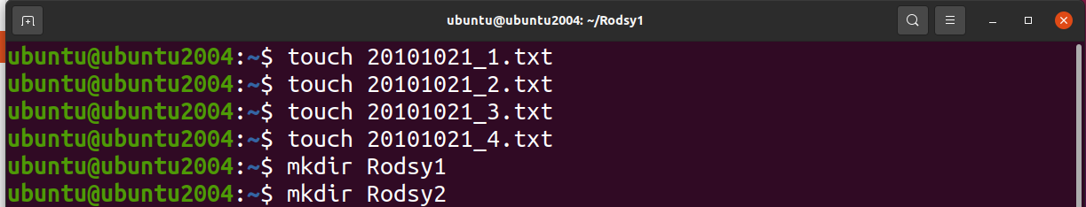

ubuntu@ubuntu2004:~$ mv 20101021_1.txt Rodsy1

ubuntu@ubuntu2004:~$ mv 20101021_2.txt Rodsy1  
ubuntu@ubuntu2004:~$ mv 20101021_3.txt Rodsy1  
ubuntu@ubuntu2004:~$ cp Rodsy1/20101021_1.txt Rodsy2  
ubuntu@ubuntu2004:~$ cp Rodsy1/20101021_2.txt Rodsy2  
ubuntu@ubuntu2004:~$ mkdir Rodsy3  
ubuntu@ubuntu2004:~$ cp -r Rodsy1 Rodsy3

ubuntu@ubuntu2004:~$ cd Rodsy3

ubuntu@ubuntu2004:~/Rodsy3$ ls -l  
total 4  
drwxrwxr-x 2 ubuntu ubuntu 4096 Feb 29 10:46 Rodsy1  
ubuntu@ubuntu2004:~/Rodsy3$ chmod go=rx *  
ubuntu@ubuntu2004:~/Rodsy3$ ls -l  
total 4  
drwxr-xr-x 2 ubuntu ubuntu 4096 Feb 29 10:46 Rodsy1

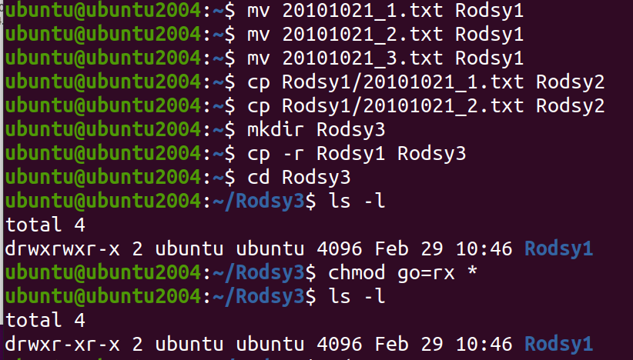

ubuntu@ubuntu2004:~/Rodsy3$ cd ..



ubuntu@ubuntu2004:~$ ls -R

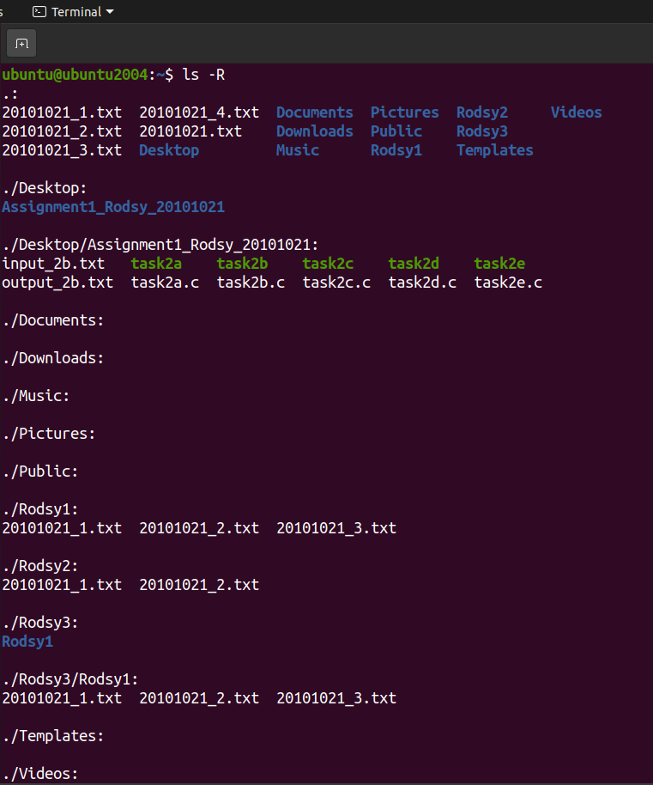

ubuntu@ubuntu2004:~$ mv Rodsy3 /  
mv: cannot move 'Rodsy3' to '/Rodsy3': Permission denied  
ubuntu@ubuntu2004:~$ sudo mv Rodsy3 /  
ubuntu@ubuntu2004:~$ rm -rf 20101021_4.txt Rodsy1 Rodsy2

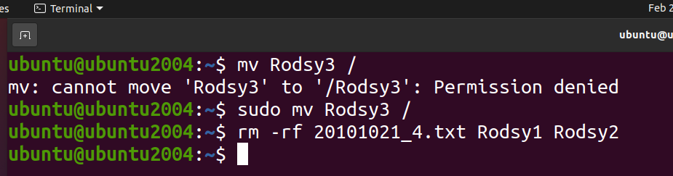

#####################################################################

Answer 1b)

ubuntu@ubuntu2004:~$ touch course.txt

ubuntu@ubuntu2004:~$ gedit course.txt

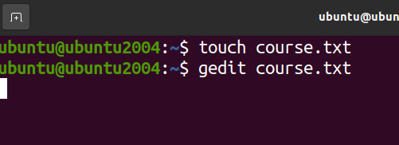

Course.txt:

My running semester's course information:

1. CSE321 Operating Systems section-12

2. CSE470 Software Engineering section-05

3. ECO101 Introduction to Microeconomics section-12

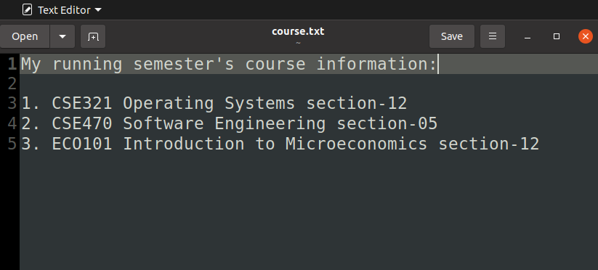

ubuntu@ubuntu2004:~$ grep -c "CSE" course.txt  
2  
ubuntu@ubuntu2004:~$

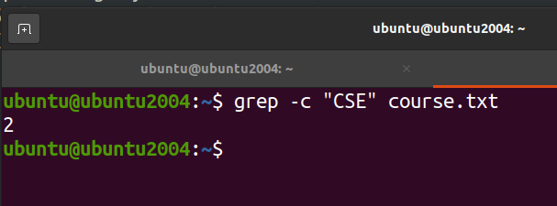

#####################################################################

Answer 1c)

ubuntu@ubuntu2004:~$ ls -a /  
.    boot   etc   lib32   lost+found  opt     root  snap  tmp  
..   cdrom  home  lib64   media       proc    run   srv   usr  
bin  dev    lib   libx32  mnt         Rodsy3  sbin  sys   var  
ubuntu@ubuntu2004:~$

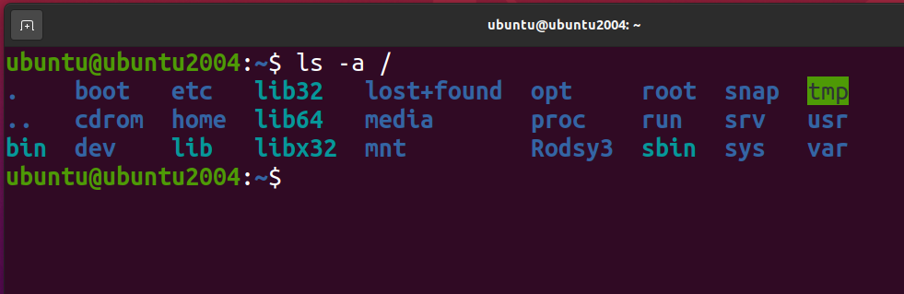

#####################################################################

Answer 1d)

ubuntu@ubuntu2004:~$ touch a.txt

ubuntu@ubuntu2004:~$ gedit a.txt

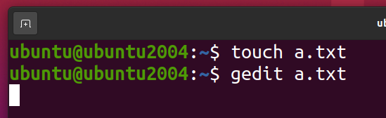

a.txt:

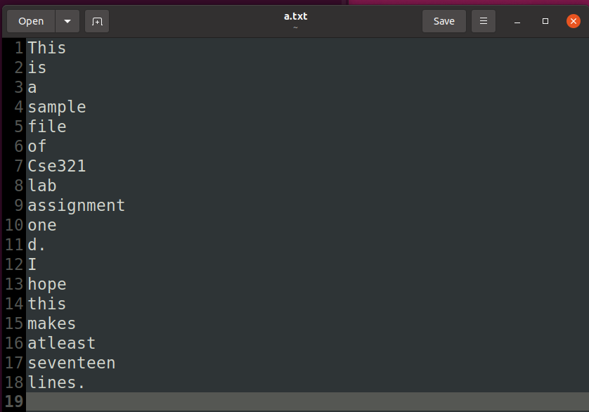

ubuntu@ubuntu2004:~$ head -n 17 a.txt | tail -n +5  
file  
of  
Cse321  
lab  
assignment  
one  
d.  
I  
hope  
this  
makes  
atleast  
seventeen  
ubuntu@ubuntu2004:~$

